|  |
| --- |
| **Volunteer Management System** **For VIA Campus Horsens Studerendes Råd** |

**Andrejs Davis Umbrovskis - 315210**

**Emilia-Georgiana Nistor - 315206**

**Hugo Daniel Da Silva Guiomar - 315172**

**Javier Abreu Barreto - 315237**

**Siddhartha Jonathan Grasse – 315278**

**Joseph Chukwudi Okika - JOOK**

**Jakob Knop Rasmussen - JKNR**

**Software Technology Engineering**

**3rd Semester**

**20/09/2022**

**Table of content**

￼

￼

￼

￼

￼

￼

￼

￼

Appendices

# Background Description

VIAUC is a Danish University College that offers students various courses regarding engineering, marketing, architecture, etc. A fundamental part of this community is the university’s student council, known as De Studerendes Råd – DSR. DSR is a student operated organization with a focus on improving student life. This is achieved through two different channels. The first and most prominent is through political activities, this means communicating directly with the university’s management and negotiating changes to the way that they operate. The second way student life is improved is through the arrangement of social activities, organizing fun activities, and making students feel welcomed into the international community of students. All who make this possible are volunteers, both managing and participating. This means that time is split between studies, work and free time and it is a valuable commodity for all members of DSR. DSR has branches in every campus, run by their respective executive boards which operate independently. With an abnormally high percentage of international students, as well as exchange students, in Campus Horsens specifically, DSR has been requested to focus on providing an excellent student environment for all cultures.

This supports the UN goal number 4 by furthering the quality of education with a comfortable study environment for VIA’s students.

With the inefficient way the organization operates currently, the time spent managing social events depletes the free time of the members, leaving no time for the political activities. If there was a more efficient way to oversee these social activities, DSR in campus Horsens would have more time to dedicate to their political activities.

At this point volunteers are tracked, assigned, and managed in Excel spreadsheets for their respective tasks and emails for communication with each other. DSR has to manage hundreds of volunteers every semester, tracking the number of shifts, rewards, and most importantly, this has to be done precisely. The current way this is managed makes it difficult, prone to human error and time consuming to say the least.

The way it is currently done differs for each committee, but the Events Committee will be used as an example that covers most of the use cases. On the one hand, permanent volunteers are tracked on an excel sheet including their names, student number, contact information and responsibility. Organizers are kept in this excel sheet as they are in charge of managing others. A different spreadsheet is used to track frequent volunteers, including name, student number, contact information and amount of shifts they have had to indicate seniority. Finally, a separate spreadsheet is used to oversee individual events, where volunteers are listed including name, contact information and what shift they must take.

This information is manually compiled by the organizers from emails, meetings and online forms which makes this a repetitive, boring, and time-consuming task. Which prevents DSR from focusing on its political functions.

DSR has contacted the development team with the following requests.

They want the system to have a sorting algorithm that checks the amount of shits and ratings of each individual volunteer. These volunteers should also be able to be awarded and rated within the system aswell have the ability to leave feedback after each shift.

DSR envisions 5 different users, the board, a chairperson, managers, leaders and volunteers. Additionally the client wants a log in system within the system, preferably using the VIA log in.

In addition to all of this, a system to manage volunteers in this way could benefit many organizations outside of VIA. Volunteering is the driving force in many different organizations and easily managing them would make a lot of organizations much more effective. This would support a great amount of the UN’s sustainable goals, that rely on a volunteering system. Examples are goal 2 “Zero Hunger” by allowing voluntary organizations like soup kitchen to organize their volunteers, and goal 3 “Clean water and sanitation” by organizing volunteers to build water purification and transport infrastructure.

# Problem Statement

**Main problem**

VIA’s DSR event organizers lose a lot of time managing volunteers for events, their rewards, as well as permanent or frequent volunteers, hindering the ability to focus on DSR’s political tasks.

1. How to save and display information about volunteers?
2. How to efficiently track volunteer participation?
3. How to efficiently handle rewards for volunteers?
4. How to assign volunteers (including their tasks) to events easier?

# Definition of purpose

The purpose of this project is to provide a more convenient way for DSR to manage its volunteers so that organizing the events will be less time consuming and more efficient.

# Delimitation

1. We will provide a log in system
2. Having 5 different user roles is going to make the system too complicated. The system is going to have 3 roles, volunteer, manager and administrator.
3. We will not establish a production environment for the system. The product will be delivered as source code.

# Methodology

The chosen methodology is Scrum which is an agile development methodology together with UP (Unified Process) which is an iterative and incremental development process that divides the development process into 4 phases: inception, elaboration, conception, and transition (What Is Scrum Methodology? & Scrum Project Management, n.d.). The Unified Process is going to be used because it is easier to control the risks since the high risks are the ones that are going to be completed first but also because it allows the adaptive capacity to deal with changing requirements throughout the development life cycle. The UP will also be used to represent models of the software system based on UML language (Osis and Donins, 2017).

Scrum depends on three main goals. Scrum Master is a role that helps organizing and developing the project according to the scrum framework and the scrum master is Andrejs Davis Umbrovskis. The product owner is a role that communicates with the customer and communicates the customers ideas and visions with the team, this role is filled by Javier Barreto Abreu. The remaining members of the group are the developers (Emilia Georgiana Nistor, Hugo Daniel da Silva Guiomar and Siddhartha Jonathan Grasse).

The group has agreed to have 10 sprints throughout the construction phase in which five of them have a length of 5 days while the ones during the semester project period have a length of 3 days which.

# Time schedule

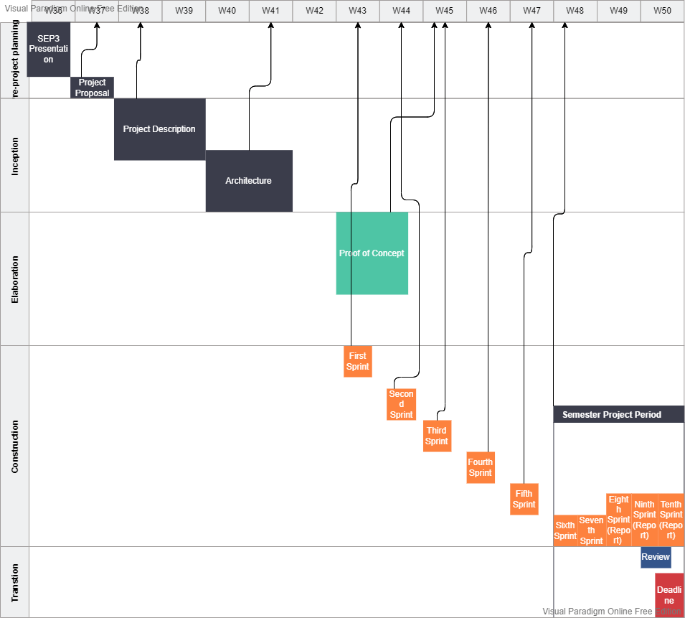

**Milestones**

|  |  |  |  |  |  |
| --- | --- | --- | --- | --- | --- |
| Phases | Unified Process | Milestone | | Deadline | Week |
| Inception | Business Modeling | Project Description | | 30/09/2022 | 39 |
|  | Architecture | | 14/10/2022 | 41 |
| Vacation | | | | | 42 |
| Elaboration | Elaboration phase start | | | | 43 |
| Requirements  Analysis and Design | Proof of Concept | 4/11/2022 | | 44 |
| Construction | Construction phase start | | | | 43 |
| Implementation | Minimum Viable Product | | 18/11/2022 | 46 |
| Test Deployment | Finished Product | | 08/12/2022 | 49 |
| Transition |  | Process and project reports done | | 14/12/2022 | 50 |
| Project review | | 14/12/2022 | 50 |

We plan to combine the elaboration phase and construction phase so we can plan what should be done first while we build our proof of concept.

According to our planning we must have our project finished by the 14th of December.

# Risk assessment

|  |  |  |  |  |  |  |
| --- | --- | --- | --- | --- | --- | --- |
| Risks | Likelihood  Scale: 1-5  5 = high risk | Severity  Scale: 1-5  5 = high risk | Product of likelihood and severity | Risk mitigation e.g. Preventive- & Responsive actions | Identifiers | Responsible |
| DSR decides they don’t need our app anymore | 1 | 5 | 5 | Stay in contact with them and explain the advantages to them | Disinterest by the party | Javier Barreto |
| VIA shuts down DSR | 2 | 5 | 10 | Support DSR in showing VIA that they are essential for the student life | Announcement on Outlook | Emilia Georgiana |
| DSR decides they don’t need volunteers for their events anymore | 1 | 5 | 5 | Explain to them that they are going to be able to plan a lot more important events if they have the help of volunteers | No more Event announcements on Facebook | Hugo Guiomar |
| There are no volunteers interested in supporting DSR | 3 | 4 | 12 | Organize rallies to catch volunteers, try to get as many people as possible interested in the programmes | No volunteers contacting DSR, DSR telling us they don’t need our app because they are not getting volunteers anymore. | Siddhartha Grasse |
| All the group members become busy with their own private lives and can’t work a lot on the project anymore | 2 | 3 | 6 | Motivate all the members to focus on the project and get the work done, tell them that the private life can wait until after the job is finished. | Group members not showing up to meetings and only working the bare minimum | Andrejs Umbrovskis |

# Sources of Information

The information pertaining to DSR has been obtained by interviewing the following members of the organization:

Erik Karsten Hougaard – Chairman of DSR at Campus Horsens

Javier Abreu Barreto – Chairman of the Events Committee at Campus Horsens

Jacob Simonsen – Head of Finance for DSR at Campus Horsens & Chairman of Konstruktør Studerendes Råd

Amaya Lopez-Malax Echeverria – Student Coordinator at VIA

Mathias Jørgensen - Chairman of DSR Campus at Aarhus C

Osis, J. and Donins, U., 2017. Software Designing With Unified Modeling Language Driven Approaches. [online] ScienceDirect. Available at: <https://www.sciencedirect.com/topics/computer-science/unified-process> [Accessed 24 September 2022].

**Appendices**

Group Contract